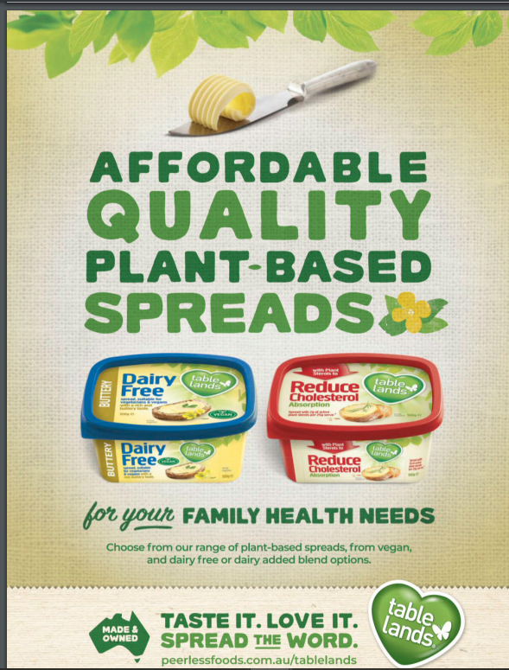.
Photo courtesy of Australian Healthy Food Guide Magazine.

